Jersey Review Website Database

Mission Statement

The purpose of the Jersey Review Website database is to collect/gather soccer teams jersey information for soccer fans, so they have a centralized application where they can review, rate and access links to purchase these jerseys.

Mission Objective

* Provide a list/collection of jerseys for different soccer teams.
* Store user reviews and ratings for jerseys on the application
* Store application user information.
* Provide affiliate links to users to make purchases externally.

Entity Relationship Model

I am building a database to collect/store soccer teams jersey information. The requirements analysis identified that I would need the following entities:

* User
* Soccer Team
* Soccer League
* Jersey
* Jersey Review
* Jersey Rating
* Wish Item
* Login Information
* Permissions

The relationships between these entities have been identified as follows:

* A **User** can add one or more **Jerseys** to the collection; A **Jersey** can be added by one and only one **User.**
* A **User** can add one or more **Soccer Team**; A **Soccer Team** can be added by one and only one **User.**
* A **User** can add one or more **Soccer League**; A **Soccer League** can be added by one and only one **User.**
* A **User** can add one or more **Players**; A **Player** can be added by one and only one **User.**
* A **User** can have one or more **Wish Items**; A **Wish Item** can be for one or more **Users.**
* A Soccer **Team** can have one or more **Soccer League**; A **Soccer League** can have one or more **Soccer Team.**
* A **Soccer Team** can have one or more **Jerseys**; A **Jersey** can be associated with one and only one **Soccer Team.**
* A **Jersey** can have one or more **Jersey Reviews**; A **Jersey Review** can be for one and only one **Jersey.**
* A **Jersey** can be for one or more **Wish Items**; A **Wish Item** can have one and only one **Jersey.**
* A **Jersey** can have one and only one **Jersey Rating**; A **Jersey Rating** can be for one and only one **Jerseys.**
* A **User** can give one or more **Jersey Reviews**; A **Jersey Review** can have one or more ratings by Users**.**
* A **User** can give one or more **Jersey Rating;** A **Jersey Rating** can have one or more rating by **Users.**
* A **User** can have one and only one **Login Information; Login Information** can be for one and only one **User.**
* A **User** can have one and only one **Login Information; Login Information** can be for one and only one **User.**
* A **User** can have one or more **Permissions**; A **Permission** can be assigned to one or more **Users.**

Entity Relationship Diagram

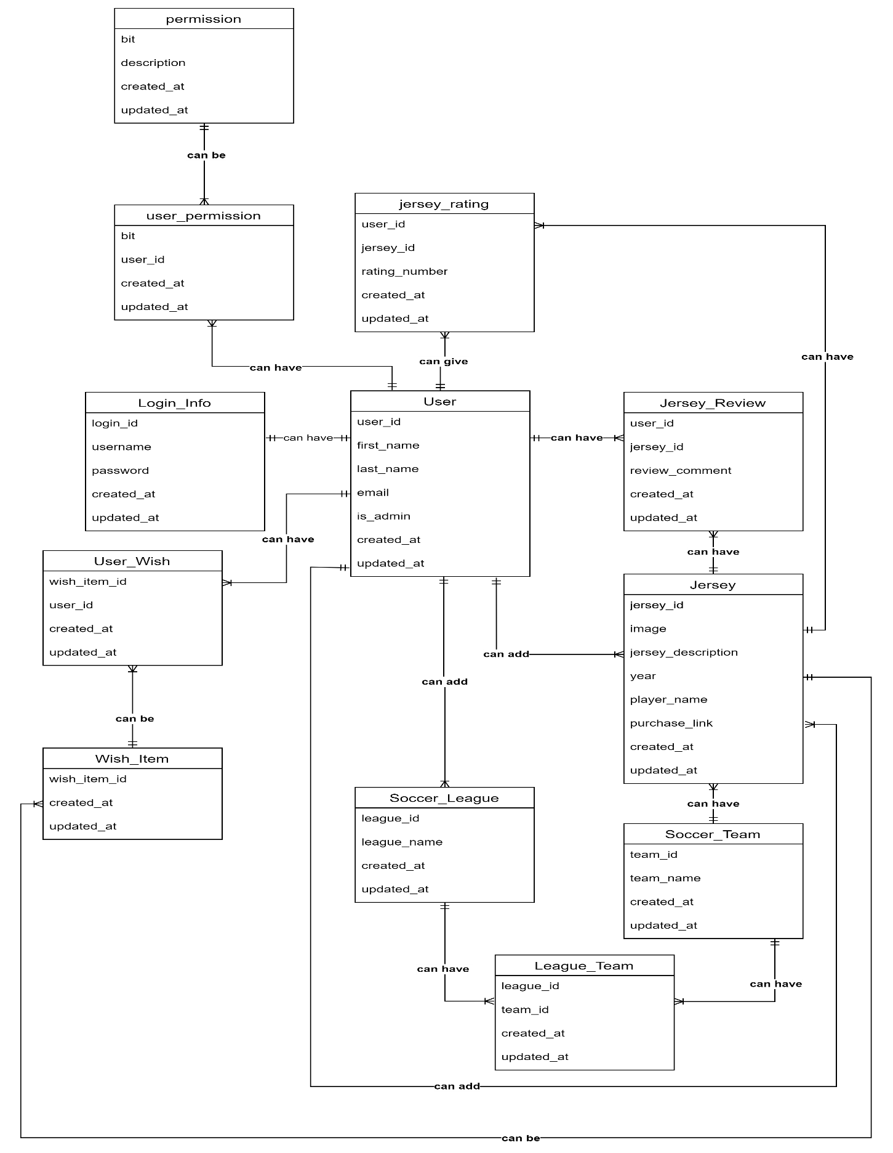

Relational Model

* User (user_id, first_name, last_name, email, is_admin(fk) created_at, updated_at)
* Soccer_Team (team_id, user_id(fk), team_name, created_at, updated_at)
* Soccer_League (league_id, user_id(fk) league_name, created_at, updated_at)
* Jersey (jersey_id, user_id(fk), team_id(fk), image, jersey_description, year, player_name, purchase_link**,** created_at, updated_at)
* Jersey_Review (user_id(fk), jersey_id(fk), review_comment, created_at, updated_at)
* Jersey_Rating (user_id(fk), jersey_id(fk), rating_number, created_at, updated_at)
* Wish_Item (wish_item_id, user_id(fk), jersey_id(fk), created_at, updated_at)
* Login_Info (login_id, user_id(fk), username, password, created_at, updated_at)
* Permissions (permission_id, description, created_at, updated_at)
* League_Team (league_id(fk), team_id(fk) , created_at, updated_at)
* User_Permissions (user_id(fk), bit(fk) , created_at, updated_at)
* User_Wish (wish_item_id(fk), user_id(fk) , created_at, updated_at)